

**Final Project**

**Parking Management System**

**Submitted by:**

Faizan Ahmad 241608482

Umm-e-Abiha 231522019

Laiba Hassan 241553066

**Submitted to:**

Sarwan Abassi

**Parking Management system:**

Parking Management System is for keeping track of all the vehicles that enter and exit a parking garage. If the car has been visited through number, it is simple for the administrator to obtain the relevant data. There is a serious issue with parking these days in many public locations, including malls, multiplex systems, hospitals, workplaces, and market areas. There are numerous lanes and parking spaces in the vehicle parking area. So, in order to park a car, one must search all the lanes. Additionally, this requires a lot of hard labor and money. The vehicle can park safely, securely, and affordably rather than being towed. A lot of secure equipment, including parking control gates, toll gates, time and attendance machines, car counting systems, etc., are included in the parking control system. These elements are therefore crucial nowadays to protect the vehicle and determine the cost associated with each vehicle's entry and exit.

The objective of this project is to build a Vehicle Parking Management System that enables the time management and control of vehicles using number plate recognition. The system that will track the entry and exit of cars, maintain a listing of cars within the parking lot, and determine if the parking lot is full or not. This system will give parking packages to the customers. The system will allocate the slot to the customer to save the time being wasted in searching the slot. Customer can easily reserve the slot as well.

**Functional Requirements**

**Employee:**

* There are 4 types of employees:

1. Administrator
2. Operator
3. Ticketor
4. Cashier

* All employees have Name(Fname,Lname) , EmpId, Email,gender,DOB,Address and working Hours.
* For Administrator, System has additional attribute which is office hours.
* For Operator, System has Floor no.
* For Ticketor, System has Gate no.
* For Cashier, System has Counter no.

**Customer:**

* Customer has five attributes:

1. Customer Id
2. Name(Fname,Lname)
3. Address
4. Email
5. DOB

**Membership:**

* Membership has 3 attributes:

1. Membership ID
2. Packages
3. fee

**Vehicle Details:**

* Vehicle entity has 3 attributes:

1. Vehicle ID
2. Vehicle type
3. Vehicle Name

**Parking Slots:**

* Parking slot has 2 attributes:

1. Slot ID
2. Status

**Receipt:**

* Receipt has 3 attributes:

1. Receipt ID
2. Packages
3. Time (Entry,Exit)

**Reservation:**

* Reservation has 3 attributes:

1. Reservation ID
2. Slot ID
3. Time (In_time , Out_time)

**Payment:**

* Payment has 2 types:

1. Cash
2. Card

* Payment has 4 attributes which are PaymentID , date , time and cash. But for card, it has card No. also.

**Reservation:**

* Reservation has only 1 field:

1. Reservation ID

**EERD:**

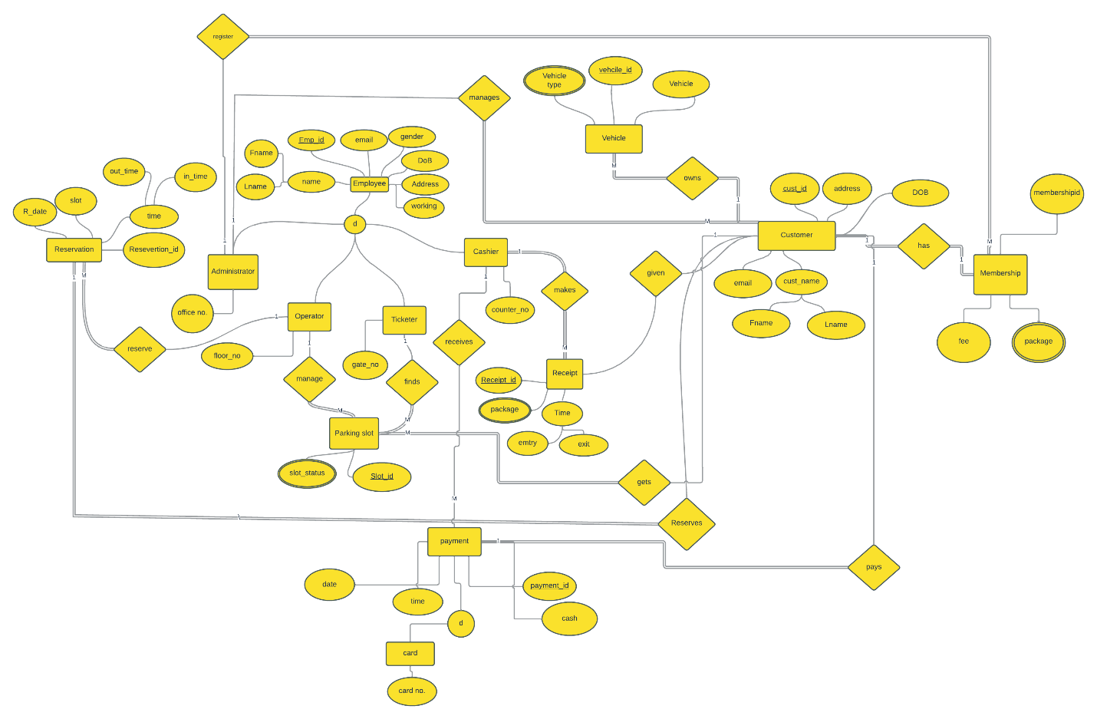

**Relational Model:**

Administrator

|  |  |  |  |  |  |  |  |  |
| --- | --- | --- | --- | --- | --- | --- | --- | --- |
| **Adm ID** | F.name | L.name | Gender | address | email | DOB | Working hour | Office no |

Operator

|  |  |  |  |  |  |  |  |  |
| --- | --- | --- | --- | --- | --- | --- | --- | --- |
| **Opr ID** | F.name | L.name | Gender | address | email | DOB | Working hour | Floor  no |

Ticketor

|  |  |  |  |  |  |  |  |  |
| --- | --- | --- | --- | --- | --- | --- | --- | --- |
| **Ticketor ID** | F.name | L.name | address | Gender | email | DOB | Working hour | Gate no |

Cashier

|  |  |  |  |  |  |  |  |  |
| --- | --- | --- | --- | --- | --- | --- | --- | --- |
| **Cashier ID** | F.name | L.name | Gender | address | email | DOB | Working hour | Counter No |

Customer

|  |  |  |  |  |  |  |
| --- | --- | --- | --- | --- | --- | --- |
| **Cust.ID** | Adm ID | Member ID | email | address | DOB | Vehicle ID |

Vehicle

|  |  |  |
| --- | --- | --- |
| **Vehicle ID** | Vehicle type | Vehicle name |

Membership

|  |  |  |  |
| --- | --- | --- | --- |
| **Membership ID** | fee | Package | Adm ID |

Receipt

|  |  |  |  |  |  |  |
| --- | --- | --- | --- | --- | --- | --- |
| **Receipt ID** | package | entry | exit | Cust.ID | Payment ID | Cashier ID |

Parking slot

|  |  |  |  |
| --- | --- | --- | --- |
| **Slot.ID** | Slot status | Cust.ID | Ticketor ID |

Reservation

|  |  |  |  |  |  |  |
| --- | --- | --- | --- | --- | --- | --- |
| **Reservation no** | Cust.ID | Slot.ID | R.date | Start time | End time | Opr ID |

Card

|  |  |  |  |  |  |  |
| --- | --- | --- | --- | --- | --- | --- |
| **Payment No** | Card no | payment | date | time | Cashier ID | Cust.ID |

Cash

|  |  |  |  |  |  |
| --- | --- | --- | --- | --- | --- |
| **Payment No** | payment | date | time | Cashier ID | Cust.ID |

**Queries:**



